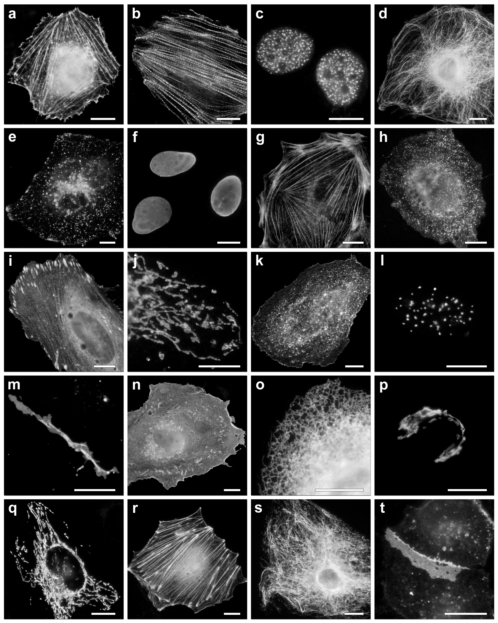
Additional Figure 2. Fluorescence imaging of mEos4b fusion vectors. (a-h) C-terminal mEos4b fusion constructs (with respect to the fluorescent protein). For each fusion, the linker amino acid length is indicated after the name of the targeted organelle or fusion partner. (a) mEos4b-β-actin-C-18 (human; target: actin cytoskeleton); (b) mEos4b-Myotilin-C-14 (human; target: actin filaments); (c) mEos4b-CAF1-C-10 (mouse; target: chromatin assembly factor); (d) mEos4b-α-tubulin-C-18 (human; target: microtubules); (e) mEos4b-LAMP1-C-20 (rat; target: lysosomes); (f) mEos4b-LaminA-C-18 (human; target: nuclear envelope); (g) mEos4b-MyosinIIA-C-18 (mouse; target: cytoskeleton); (h) mEos4b-Clathrin-C-15 (human; target: clathrin light chain B). (i-t) N-terminal mEos4b fusion vectors using the same nomenclature. (i) mEos4b-Zyxin-N-6 (human; target: focal adhesions); (j) mEos4b-TOMM20-N-10 (human translocase; mitochondria); (k) mEos4b-Caveolin-N-10 (human; target: caveolae); (l) mEos4b-CENPB-N-22 (human; target: centromeres); (m) mEos4b-Cx43-N-7 (rat α-1 connexin 43; target: gap junctions); (n) mEos4b-C-Src-N-7 (chicken; target: tyrosine kinase); (o) mEos4b-CytERM-N-17 (rabbit; target: cytochrome p450); (p) mEos4b-MANNII-N-10 (mouse mannosidase 2; target: endoplasmic reticulum); (q) mEos4b-PDHA1-N-10 (human pyruvate dehydrogenase; target: mitochondria); (r) mEos4b-Lifeact-N-7 (yeast; target: actin); (s) mEos4b-Vimentin-N-7 (human; target: intermediate filaments); (t) mEos4b-VE-Cadherin-N-10 (human; target: adhesion junctions). The cell lines used for expression of mEos4b constructs includes human cervical adenocarcinoma cells (HeLa-S3; ATCC) in panel (f), rat kangaroo kidney epithelial cells (PtK2; ATCC) in panels (b), (d), (g) and (r) and Madin-Darby canine kidney (MDCK; ATCC) cells in panel (t). HeLa CCL2 (ATCC) cells were used in the remaining panels. Scale bars represent 10 μm.

