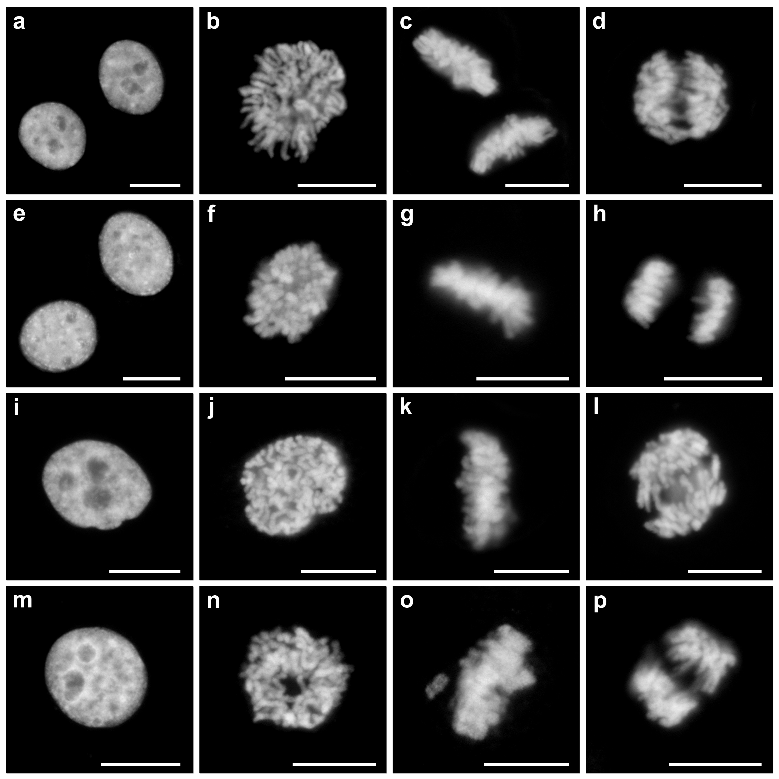
Additional Figure 3. Time-lapsed fluorescence imaging of mEos4 H2B fusion vectors. (a-d) mEos4a-H2B-C-10 (human) in HeLa S3 cells. (a) interphase; (b) prophase; (c) metaphase; (d) anaphase. (e-h) mEos4a-H2B-N-6 (human) in HeLa S3 cells. (e) interphase; (f) prophase; (g) metaphase; (h) anaphase. (i-l) mEos4b-H2B-C-10 (human) in HeLa S3 cells. (i) interphase; (j) prophase; (k) metaphase; (l) anaphase. (m-p) mEos4b-H2B-N-6 (human) in HeLa S3 cells. (m) interphase; (n) prophase; (o) metaphase; (p) anaphase. Scale bars represent 10 µm.

